IIT-JEE-Chemistry-Screening-2002
SCREENING
_______________________________________________________________________
1. How many moles of electron weighs one kilogram?
(A) 6.023 x 10²³
(B) 1/9.108 x 10³¹
(C) 6.023/9.108 x 10⁵⁴
(D) 1/(9.108 x6.023) x 10⁸
2. Which of the following volume (V) – temperature (T) plots represents the behavior of one mole of an ideal gas at the atmospheric pressure?
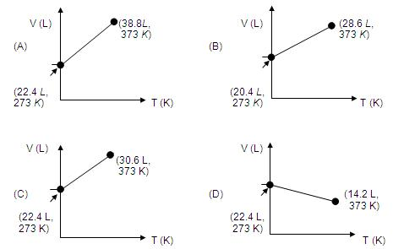
3. If the Nitrogen atom had electronic configuration 1s⁷, it would have energy lower than that of the normal ground state configuration 1s² 2s² 2p³, because the electrons would be closer to the nucleus. Yet 1s⁷ is not observed because it violates
(A) Heisenberg uncertainty principle
(B) Hund's rule
(C) Pauli exclusion principle
(D) Bohr postulate of stationary orbits
4. Rutherford's experiment , which established the nuclear model of the atom, used a beam of
(A) β-particles , which impinged on a metal foil and got absorbed
(B) γ-rays, which impinged on a metal foil and got scattered
(C) Helium atoms , which impinged on a metal foil and got scattered
(D) Helium nuclei , which impinged on a metal foil and got scattered
5. When the temperature is increased, surface tension of water
(A) Increases
(B) Decreases
(C) Remains constant
(D) Shows irregular behaviour
6. A substance A_{X} B_{Y} crystallizes in a face centered cubic (FCC) lattice in which atoms 'A' occupy each corner of the cube and atoms 'B' occupy the centers of each face of the cube. Identify the correct composition of the substance A_{X} B_{Y}
(A) AB₃
(B) A₄B₃
(C) A₃B
(D) Composition cannot be specified
7. Consider the chemical reaction N₂(g) + 3H₂(g) --> 2NH₃(g). The rate of this reaction can be expressed in terms of time derivative of concentration of N₂(g), H₂(g), or NH₃(g). Identify the correct relationship amongst the rate expressions
(A) Rate = -d[N₂]/dt = -1/3 d[H₂] /dt = 1/2 d[NH₃] /dt
(B) Rate = -d[N₂]/dt = -3 d[H₂] /dt = 2 d[NH₃] /dt
(C) Rate = d[N₂]/dt = 1/3 d[H₂] /dt = 1/2 d[NH₃] /dt
(D) Rate = -d[N₂]/dt = - d[H₂] /dt = d[NH₃] /dt
8. Standard electrode potential data are useful for understanding the suitability of an oxidant in a redox titration. Some half cell reactions and their standard potentials are given below
MnO₄⁻(aq.) +8H⁺ (aq.) +5e --> Mn²⁺ (aq.) + 4H₂O (l) E⁰ = 1.51 V
Cr₂O₇²⁻(aq.) + 14 H⁺ (aq.) + 6e --> 2Cr ³⁺ (aq.) + 7H₂O (l) E⁰= 1.38V
Fe³⁺ (aq.) + e --> Fe²⁺ (aq.) E⁰ = 0.77V
Cl₂ (g) +2e --> 2Cl⁻(aq.) E⁰ = 1.40V
Identify the only incorrect statement regarding the quantitative estimation of aqueous Fe(NO₃)₂ .
(A) MnO₄⁻ can be used in aqueous HCl
(B) Cr₂O₇²⁻ can be used in aqueous HCl
(C) MnO₄⁻ can be used in aqueous H₂SO₄
(D) Cr₂O₇²⁻ can be used in aqueous H₂SO₄
9. Specify the coordination geometry around and hybridization of N and B atoms in a 1:1 complex of BF₃ and NH₃
(A) N: tetrahedral , sp³ ; B: tetrahedral, sp³
(B) N: pyramidal, sp³ ; B: pyramidal, sp³
(C) N: pyramidal, sp³ ; B: planar, sp²
(D) N: pyramidal, sp³ ; B: tetrahedral, sp³
10. One mole of a non-ideal gas undergoes a change of state (2.0 atm. 3.0 L, 95 K ) à (4.0 atm. 5.0 L, 245 K) with a change in internal energy , DU = 30.0L atm. The change in enthalpy (ΔH) of the process in L atm is
(A) 40.0
(B) 42.0
(C) 44.0
(D) Not defined, because pressure is not constant
11. Consider the following equilibrium in a closed container
N₂O₄ (g) <--> 2NO₂
At a fixed temperature, the volume of the reaction container is halved. For this change, which of the following holds true regarding the equilibrium constant (K_{p}) and degree of dissociation (α)?
(A) Neither K_{P} nor α change
(B) Both K_{P} and α change
(C) K_{P} changes, but α does not change
(D) K_{P} does not change, but α change
12. Which of the following hydrocarbons has the lowest dipole moment ?
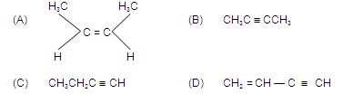
13. Compound ‘A’ (molecular formula C₃H₈O)is treated with acidified potassium dichromate to form a product ‘B’ (molecular formula C₃H₆O) ‘B’ forms a shining silver mirror on warming with ammoniacal silver nitrate. ‘B’ when treated with an aqueous solution of H₂NCONHNH₂ and sodium acetate gives a product ‘C’. Identify the structure of ‘C’
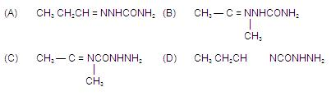
14. Identify the correct order of reactivity in electrophilic substitution reactions of the following compounds
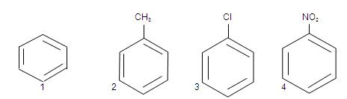
(A) 1>2>3>4
(B) 4>3>2>1
(C) 2>1>3>4
(D) 2>3>1>4
15. Identify the correct order of boiling points of the following compounds
CH₃ CH₂CH₂CH₂OH CH₃ CH₂CH₂CHO CH₃ CH₂CH₂COOH
1 2 3
(A) 1>2>3
(B) 3>1>2
(C) 1>3>2
(D) 3>2>1
16. Identify the set of reagents / reaction conditions 'X' and 'Y' in the following set of transformations
CH₃ - CH₂ - CH₂Br --X-> product --Y-> CH₃ - CH - CH₃
|
Br
(A) X = dilute aqueous NaOH, 20⁰C; Y =HBr / acetic acid, 20⁰C
(B) X = concentrated alcoholic NaOH, 80⁰C; Y =HBr / acetic acid, 20⁰C
(C) X = dilute aqueous NaOH, 20⁰C; Y = Br₂/ CHCl₃, 0⁰C
(D) X = concentrated aqueous NaOH, 80⁰C; Y = Br₂/ CHCl₃, 0⁰C
17. Identify a reagent from the following list which can easily distinguish between 1-butyne and 2-butyne
(A) Bromine, CCl₄
(B) H_{2,} Lindlar catalyst
(C) Dilute H₂SO_{4,} HgSO4
(D) Ammoniacal CuCl₂ solution
18. Consider the following reaction
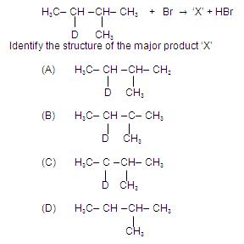
19. Which of the following acids has the smallest dissociation constant?
(A) CH₃CHFCOOH
(B) FCH₂CH₂COOH
(C) BrCH₂CH₂COOH
(D) CH₃CHBrCOOH
20. Which of the following compounds exhibits steroisomerism?
(A) 2-methylbutene- 1
(B) 3-methylbutyne-1
(C) 3-methylbutanoic acid
(D) 2-mtethylbutanoic acid
21. The nodal plane in the Π-bond of ethane is located in
(A) The molecular plane
(B) A plane parallel to the molecular plane
(C) A plane perpendicular to the molecular plane which bisects the carbon - carbon σ-bond at right angle
(D) A plane perpendicular to the molecular plane which contains the carbon - carbon σ-bond
22. Polyphosphates are used as water softening agents because they
(A) Form soluble complexes with anionic species
(B) Precipitate anionic species
(C) Form soluble complexes with cationic species
(D) Precipitate cationic species
23. Identify the correct order of acidic strengths of CO₂, CuO, CaO, H₂O
(A) CaO< CuO< H₂O<CO₂
(B) H₂O <CuO< CaO <CO₂
(C) CaO<H₂O<CuO<CO₂
(D) H₂O<CO₂<CaO<CuO
24. Identify the least stable ion amongst the following
(A) Li⁻
(B) Be⁻
(C) B⁻
(D) C⁻
25. Which of the following molecular species has unpaired electrons (s)?
(A) N₂
(B) F₂
(C) O₂⁻
(D) O₂²⁻
26. A gas 'X' is passed through water to form a saturated solution. The aqueous solution of treatment with silver nitrate gives a white precipitate. The saturated aqueous solution also dissolves magnesium ribbon with evolution of a colourless gas 'Y'. Identify 'X' and 'Y'.
(A) X =CO₂, Y= Cl₂
(B) X =Cl₂, Y= CO₂
(C) X =Cl₂, Y= H₂
(D) X =H₂, Y= Cl₂
27. An aqueous solution of a substance gives a white precipitate on treatment with dilute hydrochloric acid, which dissolves on heating. When hydrogen sulfide is passed through the hot acidic solution, a black precipitate is obtained. The substance is a
(A) Hg₂²⁺ salt
(B) Cu²⁺ salt
(C) Ag⁺ salt
(D) Pb²⁺ salt
28. Which of the following process is used in extractive metallurgy of magnesium?
(A) Fused salt electrolysis
(B) Self reduction
(C) Aqueous solution electrolysis
(D) Thermite reduction
29. Identify the correct order of solubility of Na₂S, CuS and ZnS in aqueous medium
(A) CuS > ZnS > Na₂S
(B) ZnS > Na₂S > CuS
(C) Na₂S > CuS > ZnS
(D) Na₂S > ZnS > CuS
30. Anhydrous ferric chloride is prepared by
(A) Heating hydrated ferric chloride at a high temperature in a stream of air
(B) Heating metallic iron in a stream of dry chlorine gas
(C) Reaction of ferric oxide with hydrochloric acid
(D) Reaction of metallic iron with hydrochloric acid

